3B Biological Sciences

Test 1 – DNA technology

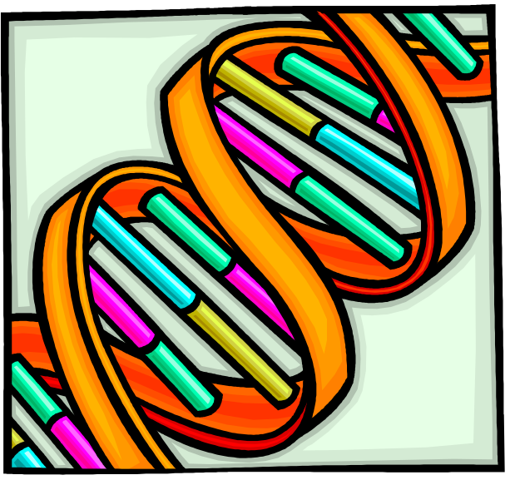
Microsoft clipart

This test consists of two parts

Part A – Multiple Choice – 20 marks
Part B – Extended Answer – 30 marks

PLEASE DO NOT MARK THIS question booklet

Part 1 – Multiple Choice (20 marks)

Mark the most correct response on the answer sheet provided

- A molecule of messenger RNA is transcribed from DNA;

  - on the ribosomes.
  - in the cytosol.
  - in the nucleus.
  - only during cell division.

- In recombinant DNA technology, the enzyme used to join fragments cut by a restriction enzyme is;

  - DNA ligase.
  - restriction nucleases.
  - DNA polymerase.
  - RNA polymerase.

- DNA replication is called semi-conservative because the new strand contains how much of the original strands DNA?

  - None.
  - Most.
  - Half.
  - All.

- The genome for a new virus is analysed and its DNA is made up of 17% Adenine. The % of cytosine would be;

  - 17%.
  - 33%.
  - 66%.
  - Cannot be determined from the information given.

- An actively dividing bacterial culture is grown in a medium containing radioactive adenine (A*). After all the adenine is labelled, the bacteria are transferred to a medium containing nonradioactive adenine (A). Following one round of DNA replication in the nonradioactive medium, the DNA is analysed. Which of the following sequences could represent this DNA?

  - A* A* T T G A* T C
T T A A C T A G
  - A* A T T G A* T C
T T A* A* C T A G
  - A A T T G A T C
T T A A C T A G
  - A* A* T T G A* T C
T T A* A* C T A* G

- Triplets of nucleotide bases code for;

  - A single protein.
  - A singe amino acid.
  - A several proteins.
  - A nucleic acid.

- Protein synthesis occurs in the;

  - Nucleus.
  - Smooth endoplasmic reticulum.
  - Ribosomes.
  - Cytoplasm

- A “transgenic organism” is an organism containing inserted;

  - chromosomes.
  - proteins.
  - enzymes.
  - genes.

- Polymerase chain reaction has increased the rate at which genes have been identified because;

  - It enables scientists to compare genes from one individual to another.
  - It enables long sections of DNA to be replicated.
  - It makes short sections of DNA visible to the naked eye.
  - It enables small fragments of DNA to replicate rapidly.

- At the beginning of genetic recombination the donor DNA and the plasmid DNA are placed in the same solution of restriction nuclease. This is so that;

  - the donor DNA and the plasmid DNA are cut at the same gene.
  - the DNA from the donor cell can be isolated.
  - the donor gene can bond with the plasmid.
  - the donor DNA and plasmid DNA can be replicated.
3B Biological Sciences

Test 1 – DNA Technology

Name _______________________________________________________________________

Part 1 - Multiple choice answers 10 marks

Indicate the correct answer for each question below.

1 | [A] | [B] | [C] | [D] |  | 6 | [A] | [B] | [C] | [D]
2 | [A] | [B] | [C] | [D] |  | 7 | [A] | [B] | [C] | [D]
3 | [A] | [B] | [C] | [D] |  | 8 | [A] | [B] | [C] | [D]
4 | [A] | [B] | [C] | [D] |  | 9 | [A] | [B] | [C] | [D]
5 | [A] | [B] | [C] | [D] |  | 10 | [A] | [B] | [C] | [D]

Part 2 – Extended Answer 30 marks

Question 11 has four parts, you must answer TWO. Question 12 has two parts, you must answer ONE. Each part carries ten marks.

Answers may be presented in a combination of different ways provided they communicate your ideas effectively. You may choose to:
- present a clearly labelled diagram or flow chart;
- write notes besides a clear diagram;
- write lists of points, with sentences which link them;
- write concisely worded sentences;
- use some other appropriate way to present ideas.

Question 11 – This question has four parts, answer any TWO parts from this question.

- Describe the process of DNA profiling. Give an example of how this process can be used in environmental conservation.

- Discuss potential applications of transgenic organisms in agriculture. In your response outline the advantages and concerns related these applications.

- Describe the process of protein synthesis, including the enzymes and organelles involved.

- Explain the process of gene cloning and give examples of its practical applications.

CONTINUE ON TO NEXT PAGE

Question 12 – this question has two parts, answer ONE part of from this question.

- Hair tubes are commonly used in monitoring programs for small to medium sized mammals in Western Australia. A hair tube is a cone shaped structure lined with double sided tape, with a container for attractant bait at the narrow end of the tube. The animals smell the bait and put their head in the tube in an attempt to get to the bait (which is contained in such a way that it can not be removed) and small samples of hair are stuck to the sticky tape. Several individuals can leave samples in the trap over a period of several days, making it a cost effective way of monitoring species abundance in mammal communities. Commonly the hair samples are be analysed under a microscope to identify the species of mammal. If further information is required DNA can be extracted from the samples and analysed.

Outline the procedures that may be used to remove and analyse the DNA from hair samples and the benefits this may have to conservation programs for mammals in Western Australia.

- With challenges such as reduced rainfall, poor soil fertility and increased demand for food, fibres and biofuels, increased productivity is required of Australia’s limited agriculturally viable land. The production of genetically modified crop species aims to increase productivity, reduce the use of pesticides and decrease the amount of water required to produce mature, viable plants.

Describe the processes used to produce a genetically modified plant species, outlining the procedures that may be used to introduce gene into the plant material and any difficulties that may be encountered.

